Resources for Community Engagement
“Unteachable and Difficult – Understanding Childhood Trauma”

Boys and Girls Clubs of Bloomington
The Boys and Girls Club strives to enable all young people, especially those who need us most, to reach their full potential as productive, caring, responsible citizens. https://bgcbloomington.org/

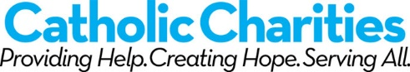Catholic Charities Bloomington
Catholic Charities Bloomington is dedicated to the enhancement of the dignity and functioning of all persons in the community-at-large though education, social services delivery and advocacy. https://www.archindy.org/index.html

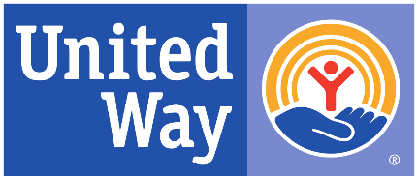
United Way of Monroe County
United Way works to improve people’s lives by mobilizing the caring power of our community. They address critical needs today and work to reduce those needs tomorrow. https://www.monroeunitedway.org/
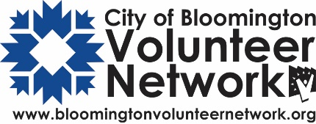
City of Bloomington Volunteer Network
CBVN seeks to build a strong, healthy and engaged community by connecting volunteers of all ages with opportunities to serve and by providing resources to volunteers and agencies in order to build creative and effective volunteer projects, programs and partnerships. https://bloomington.in.gov/volunteer

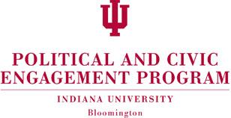
Political and Civic Engagement (PACE)
The Political and Civic Engagement program (PACE) cultivates knowledge, develops leadership, and builds communication skills to prepare members of the Indiana University community to take action for positive change. https://pace.indiana.edu/

