Contact Your Lawmakers

U.S Representative:
Honorable Rep. Trey Hollingsworth (District 9)
Phone: 812.288.3999
Mail: 279 Quartermaster Court Jeffersonville, IN 47130

U.S. Senators:
Honorable Sen. Todd Young
Phone: 202.224.5623
Mail: 46 E. Ohio St. Suite 462 Indianapolis, IN 46204

Honorable Sen. Mike Braun
Phone: 202.224.4814
Mail: 115 N. Pennsylvania St. Indianapolis, IN 46204

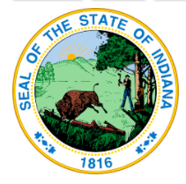
IN. State Representative:
Honorable Rep. Matthew Pierce (District 61)
Phone: 800.382.9842
E-mail: h61@iga.in.gov
Mail: 200 W. Washington St. Indianapolis, IN 46204

IN. State Senator:
Honorable Sen. Mark Stoops (District 40)
Phone: 317.232.9404
E-mail: s40@in.gov
Mail: 200 W. Washington St. Indianapolis, IN 46204

Live outside of Bloomington? Find your representatives online!
- Go to iga.in.gov
- Click on the “Find Your Legislator” tab near the bottom of the page or click the “Information” drop down tab and then click “Find your Legislator” on the drop down list.
- Fill in your address in the designated spaces and press “search”

Monroe County Board of Commissioners
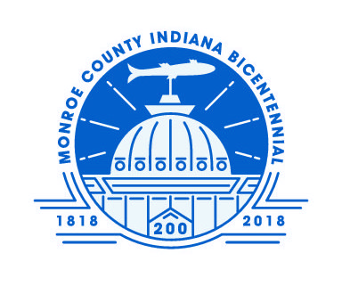
Honorable Julie Thomas: jthomas@co.monroe.in.us
Honorable Lee Jones: ljones@co.monroe.in.us
Honorable Penny Githens: pgithens@co.monroe.in.us
Phone: 812.349.2550
Mail: 100 W. Kirkwood Ave, Bloomington, IN. 47404

Monroe County Council
Honorable Shelli Yoder (District 1)
Honorable Kate Wiltz (District 2)
Honorable Marty Hawk (District 3)
Honorable Eric Spoonmore (District 4)
Honorable Trent Deckard (At-Large)
Honorable Geoff McKim (At-Large)
Honorable Cheryl Munson (At-Large)

Find Contact information for all Monroe County Council members at https://www.co.monroe.in.us/council/.

Find your county council district on the map on this page: https://www.co.monroe.in.us/egov/documents/1531670654_39718.pdf

City of Bloomington Mayor
Honorable John Hamilton
Phone: 812.349.3406
E-mail: hamiltoj@bloomington.in.gov
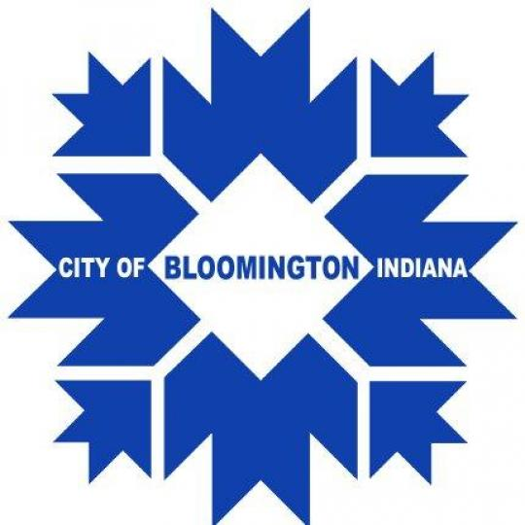
Mail: 410 N. Morton St. #210, Bloomington, IN 47404

City of Bloomington Common Council
Honorable Chris Sturbaum (District 1)
Honorable Dorothy Granger (District 2)
Honorable Allison Chopra (District 3)
Honorable Dave Rollo (District 4)
Honorable Isabel Piedmont-Smith (District 5)
Honorable Steve Volan (District 6)
Honorable Andy Ruff (At-Large)
Honorable Susan Sandberg (At-large)
Honorable Jim Sims (At-Large)

Find Contact information for all Council members at https://bloomington.in.gov/council

Find your city council district at https://bloomington.in.gov/mybloomington/

